Online Inventory Management System

END-TERM REPORT

BACHELOR OF TECHNOLOGY

in

COMPUTER SCIENCE AND ENGINEERING

By:
Group no. - 7
Sl. No | Name | Roll Number | Registration Number
1 | Satyam Tripathi | 22 | 11903767
2 | Sriyansa Mohanty | 13 | 11903787

Project Link - https://github.com/satyam12345678/INT213-Project

Courses Code: INT213



School of Computer Science and Engineering

Lovely Professional University Phagwara, Punjab (India)

Objective

The primary objective of this project is to implement what we have learnt throughout our course of Python programming and use that to develop a Graphical User Interface (GUI) for Online Inventory Management System with all the required functionalities. This project also aims at providing a user-friendly interface to the users to let them easily use the Online Inventory Management System so that the lack of knowledge in fitness to no hindrance in achieving their fitness goals. Through this project we will be helping the sellers in different shops to organize their products into a list so that it becomes easy for them while a customer pays for it and they can easily print the bill without any extra work. This project will help the people in managing the items in their shop as they come.

With the Online Inventory Management System, it becomes easy for the seller to create bills while also providing the required discount and calculate the change that the customer must receive. There are different modules that we have provided on our interface such as List of Items, Search Screen, Entering the quantity, discount for the items, Bill, Adding, Updating and Deleting Items in the list, etc. Based on all these parameters we also provided the ability to calculate change and give discounts in the bill. In this way, it will be easier for the seller to manage the bill properly.

This project is user friendly and easy to use by anyone who is managing a store. It provides an interactive interface which is easy to be managed. The ability to add, delete and update the products list provides an advantage for the seller to organize the list without any fuss.

Introduction & Modules

Inventory management is essentially a variety of techniques, tools and technologies that a business uses to manage and control their inventory. The way it is used and applied varies from simple to complex functionality. We have went for the simple version to provide with the basic functionality that a seller might require. It is an important software for companies which focus on selling and getting products very often as it makes the product organization easier. With our project a seller can easily add items to the database as the stock comes in, and then update it if there is an increase in the stock or price. The seller can easily apply discounts, calculate the change and generate the bill accordingly. The user interface is easy to use and can be managed without any extra efforts. The project comprises of different modules which are linked together to make it work without any error.
The modules are:

Main Screen

This is the first screen that displays when we run the program. It contains all the information of the complete program and links to all the other modules like searching for items, adding or updating items, generating the bill, etc. This is the core-module that connects every other module and displays all the necessary information in the front page itself.
When we first open the program, we are welcomed with a blank screen where we will have to search for the item in the Search Box according to their Product Number mentioned in the Items List. Once done, we have to enter the quantity and if there is any discount on the item, and then we move forward to generate the bill and the change that we need to provide the customer according to the amount he pays.

Item List

The “View List” button present on the top of the Main Screen takes us to the List View of the Products that are available. The List displays the name of the Product along with their Product ID, Price and the stocks left. The list also displays the Cost Price and Sale Price which can later be considered if the seller decides to give a discount to the customer. The seller can add or remove items from the list, or update their price, cost or number of stocks by using different modules.

Adding Items to List

In the left section of the screen, there are three buttons present at the bottom which include Update, Add, Delete. Clicking on “Add” sends you to the section where you can add items to the Items List.
You are presented with option enter “Product ID”, “Product Name”, “Stocks”, “Cost Price”, “Sale Price”. On the right side of the screen you can see the Product IDs that are already in use and you can click the “View List” button in order to check the list of items. If you enter an already used Product ID, or leave it empty you are presented with an Error. The error reads: “ID Empty or Already in Use”.

Updating the Items in the List

In the left section of the screen, there are three buttons present at the bottom which include Update, Add, Delete. Clicking on “Update” takes you to the screen where you can update the items present in the Items List.
You are presented with option enter “Product ID”, “Product Name”, “Stocks”, “Cost Price”, “Sale Price”. Once you enter the Product ID, you can search for the product in the database. Searching for the ID which is present in the database will display all the details of that item in the boxes which you can then edit. You can edit every detail of the item. If you enter a Product ID which is not present, it will show you an error reading: “ID Incorrect”. On the right side of the screen you can see the Product IDs that are already in use and you can click the “View List” button in order to check the list of items.

Deleting Items in the List

Clicking on the “Delete” button takes you to the section where you can delete the items present in the Items List. You are presented with option enter “Product ID”, “Product Name”, “Stocks”, “Cost Price”, “Sale Price”. Once you enter the Product ID, you can search for the product in the database. Searching for the ID which is present in the database will display all the details of that item in the respective boxes. You can check the details and then you can proceed to remove it from the list by clicking on the “Delete from Database” button.

Product Quantity, Discount and Calculating Change

The seller must add the product to the bill by searching for the Product ID as mentioned in the List. Once the seller has searched for the item, he can choose the quantity the customer wants. Once done, the seller can also assign the discount amount which is optional. Once, everything is ready and finalized he can add the items to the cart and generate the bill. The seller can also enter the amount the customer gave him in order to know how much change the customer must receive. This module is the main working part of the Project, as it does all the mathematical calculations and generates the bill with the correct amount after checking the quantity and discount. If the seller exceeds the quantity than what is present with them, the software will show an error mentioning that the stock is not available for the mentioned quantity, seeing which the seller can recheck the stock from the Items List and proceed with the bill after that. The error message reads: “Not that many products in our stock”.

Bill

The right side of the screen is completely dedicated for the Bill with the date on top of the panel. Once the user clicks on the “Add to Cart” button after choosing the Product, its Quantity and Discount, the Item appears on the right side of the screen. After the seller has added all the products correctly, he can see the total cost of the Products. Once the customer has handed him the cash, he can then enter the amount in the left side of the screen to calculate the change. Once everything has been completed the seller can click on the “Generate Bill” button and then proceed with the next customer.

Confirmation Dialogue Box

Once the seller has added everything properly to the cart, calculated the change and is ready to present the bill to the customer he can click on the “Generate Bill” button on the bottom-left side of the screen. Clicking this will present you with the message: “Done Everything Smoothly” which means that everything has run successfully, and you can move on to create the next bill.

Libraries Used (tkinter, sqlite3, datetime, math, os)

- Tkinter

The basic GUI library for Python is Tkinter. Python offers a quick and simple way to build GUI applications when coupled with Tkinter. Tkinter provides the Tk GUI toolkit with a strong object-orientated interface. It is an simple task to build a GUI application using Tkinter.
Compared to other frameworks, TKinter is lightweight and relatively painless to use. This makes it a compelling choice for building Python GUI applications, particularly for applications where a the modern touch is unnecessary, and quickly building something that is usable and cross-platform is the top priority.

- Sqlite3
SQLite is a C library that offers a lightweight disk-based database that needs no separate server process and allows a non-standard version of the SQL query language to be used to access the database. SQLite can be used for some applications for internal data storage. It is also possible to use SQLite to prototype an application and then port the code to a larger database like PostgreSQL or Oracle.
In general, SQLite is a database without a server that you can use in almost all programming languages, including Python. Server-less means that to operate with SQLite, you do not need to instal a separate server so that you can connect directly to the database. SQLite is a lightweight database that can provide zero-configuration for a relational database management system so there is no need to setup or set up anything to use it.

- Datetime
For the manipulation of dates and times, the datetime module offers classes.
Although date and time arithmetic is provided, successful attribute extraction for output formatting and manipulation is the objective of the implementation.
In both basic and complex ways, the datetime module offers classes for manipulating dates and times. Although date and time arithmetic is provided, successful attribute extraction for output formatting and manipulation is the objective of the implementation. See also the time and calendar modules for similar features.
There are two types of artefacts for date and time: "naive" and "conscious."
A conscious object has sufficient knowledge of applicable algorithmic and political time changes to locate itself relative to other conscious objects, such as time zone and daylight saving time data,
In comparison to other date / time objects, a naive object does not contain sufficient details to unambiguously locate itself.

- Math Library

Python has a built-in module for mathematical tasks that you can use. There is a set of methods and constants in the math module. In Python, the math module is a regular module and is always available. You need to import the module using import.math to use mathematical functions under this module.
Few functions of the library include:
Math.ceil(), math.log(), math.radians(), math.sqrt(), math.trunc(), math.pi(), math.e(), etc.

- OS Library
Python's OS module includes functions to communicate with the operating system. OS, is available under the basic utility modules of Python. This module offers a portable way of using features based on the operating system. Many functions for communicating with the file system are included in the *os* and *os.path* modules.
It is possible to automatically perform many operating system tasks. The OS module in Python provides functions for creating and removing a directory (folder), fetching its contents, changing and identifying the current directory, etc.
Few functions of the library include:
os.name, os.getcwd(), os.error, os.popen(), os.close(), os.rename() , etc.

Work by each group member

- Sriyansa Mohanty

- View List : This let’s the user see a complete list of all the items that are stored in the database in a tabular format. The list gets updated as soon as any change is made in the database. This module uses tkinter and sqlite3 libraries. This page also contains a “Go Back” button to exit the page.
- Add Item : This module lets you add new items to the inventory. User can add items by creating a unique id that will identify that item from the inventory. And as soon as you add an item, the added item’s id is reflected on the text box to confirm it’s insertion in the inventory. In addition to that a message box appears on the screen confirming that the item has been added to the database. This page contains a “View List” button in case you need to see what items has already been added to the database. It also has a “Go Back” button to exit the page. It has also has two more buttons “Add to Database” which is used to add the product details filled to the database, and “Clear Fields” which is used to clear the Entry fields so that the user doesn’t have to delete the previous entries when adding a new item.
- Dialogue Boxes : In the whole project there are several dialogue boxes or message boxes that confirms the transaction made by the database. For ex.
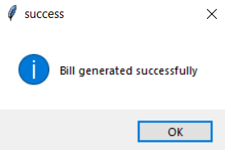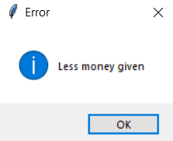
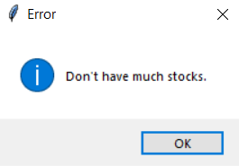 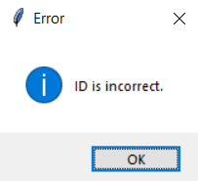etc.

- Satyam Tripathi

  - Delete from database : This allows the user to delete an item from the database. User can enter the ID and search it. On clicking the “Search” button, all the details of that product shows up. The user can confirm that he is deleting the correct item and hen click on “Delete from Database” button to permanently delete the item from inventory. There is also a Textbox containing all the IDs of existing items. As soon as the item is deleted, that item’s ID is automatically deleted from the Textbox. There are 2 more buttons, “View List” which lets the user to view whole list of items, and “Go Back” that lets the user to close the window.

  - Update to the database : This allows the user to update a specific record in the database. The user can see the existing item’s IDs on the Textbox and enter it on the Entry. Then clicking on “Search” button shows all the product details which the user can edit and save by clicking on “Update to the Database” button. There are 2 more buttons, “View List” which lets the user to view whole list of items, and “Go Back” that lets the user to close the window.
  - Main Screen : This is the interface that user opens to access all the features of the “Inventory Management System”. On the left side the user can enter the ID of the item the customer wants to purchase and then click on “Search” button. This will show the Name and Price of the searched item and now the user can enter quantity of that item to be purchased. Then the user can add any discount if applicable on the purchase. Then the user can click on “Add to cart” button that
decreases the available stocks in the inventory and outputs all its details on the right Frame. The user can add multiple items to the customer’s cart. The total amount is automatically calculated at the bottom of right Frame. User can also view the list of all items by clicking on “View List” button to make sure correct stocks are entered. In case user enters any wrong details then error message appears on the screen, for ex. “Incorrect ID entered”, “Not much stocks” etc. After user has entered all the items and the customer is ready to checkout, the user can click on “Generate Bill” button which will decrease the bought items from the inventory. This module also helps in calculating change money. I the customer pays extra money, it will calculate the money to be returned to the customer. And in case customer gives less amount of money than he is supposed to then an ERROR message appears on the screen saying “Less Money Given”. At last there are three buttons “Add”, “Update” and “Delete” to access their respective windows so that the user can make necessary changes on the database.

GUI Screenshots:

- MAIN SCREEN:

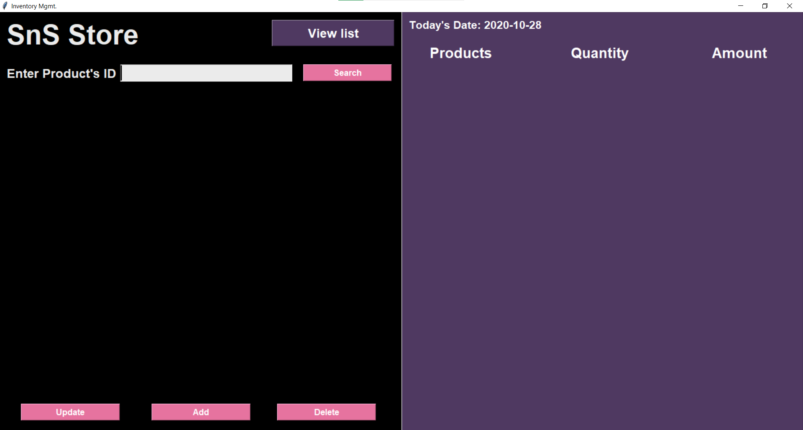

- ITEMS LIST
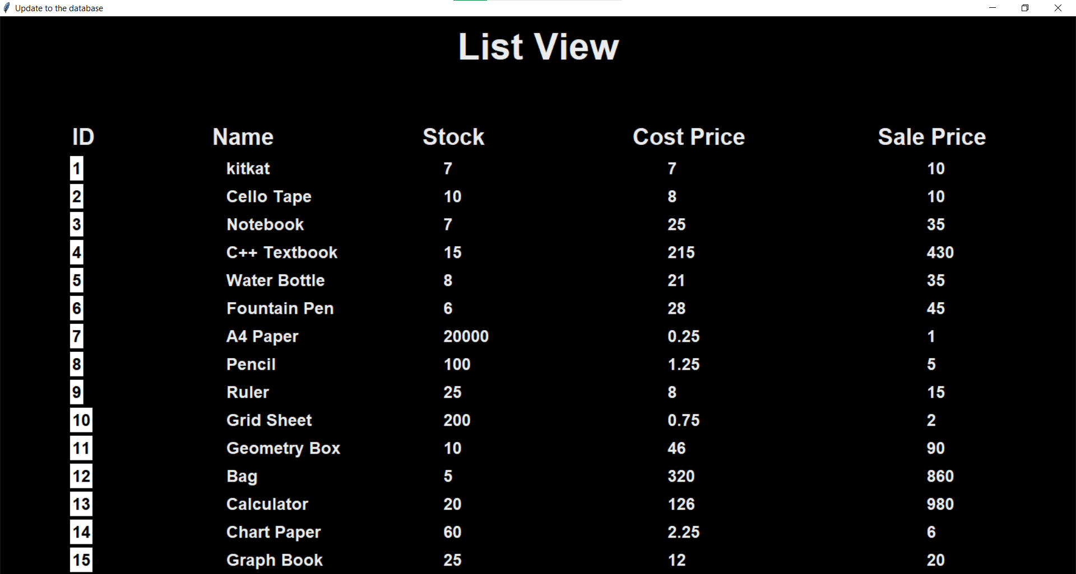

- ITEM DETAILS AFTER GETTING SEARCHED
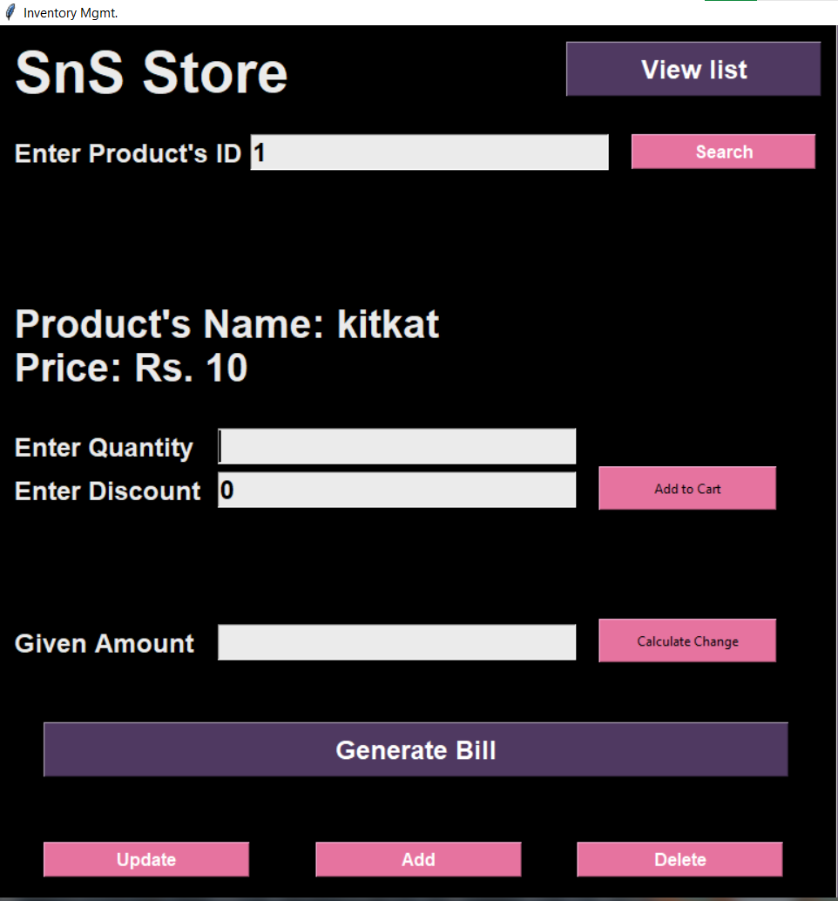

- BILL (on clicking ‘Add to Cart’)
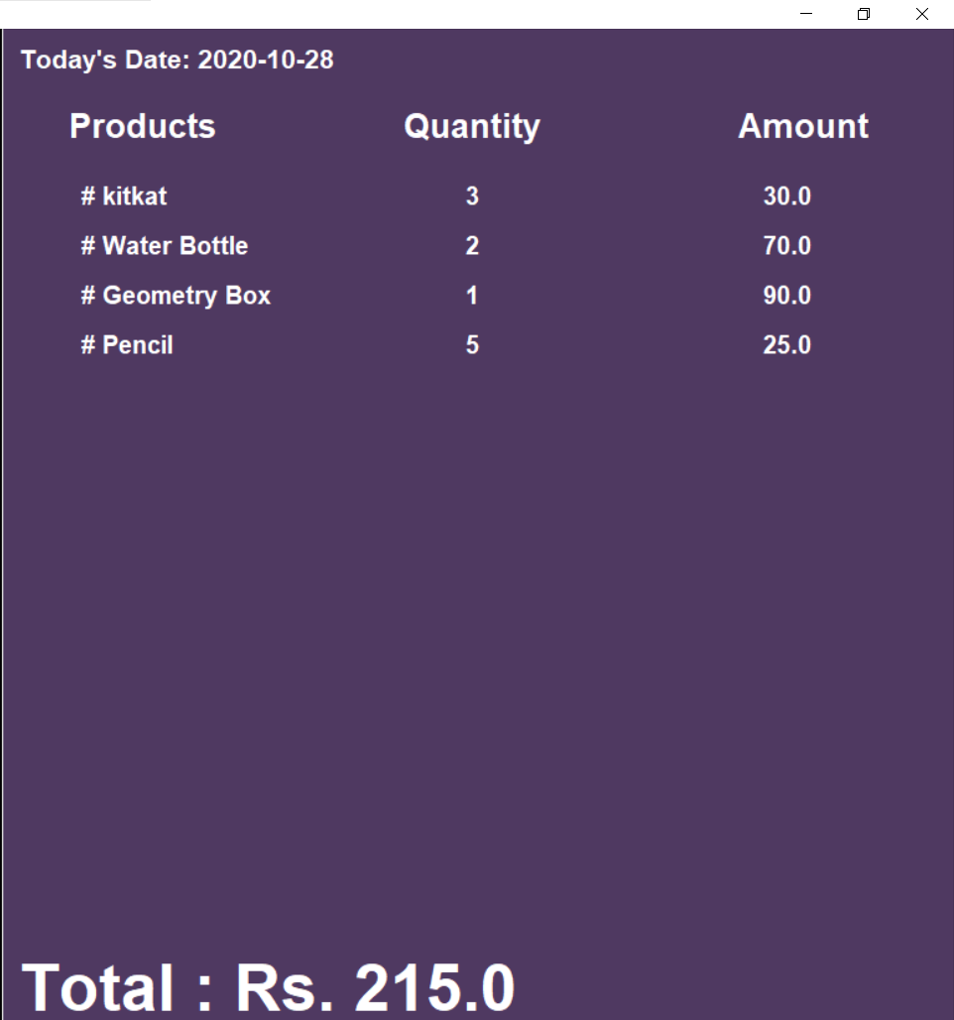

- ADDING ITEMS TO DATABASE (after clicking ‘Add’ Button, with input values)
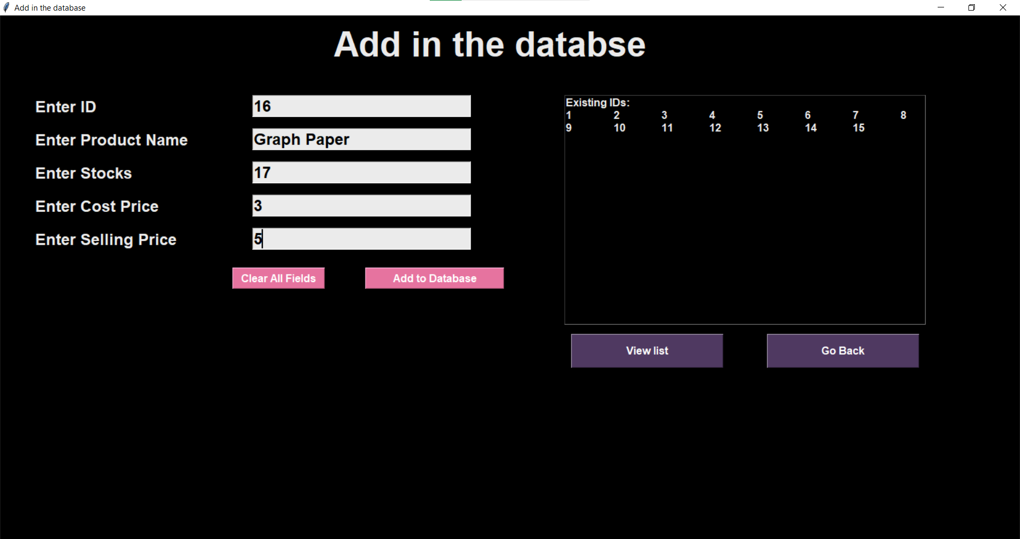

- UPDATING ITEMS IN DATABASE (after clicking ‘Update’ Button, with input values)
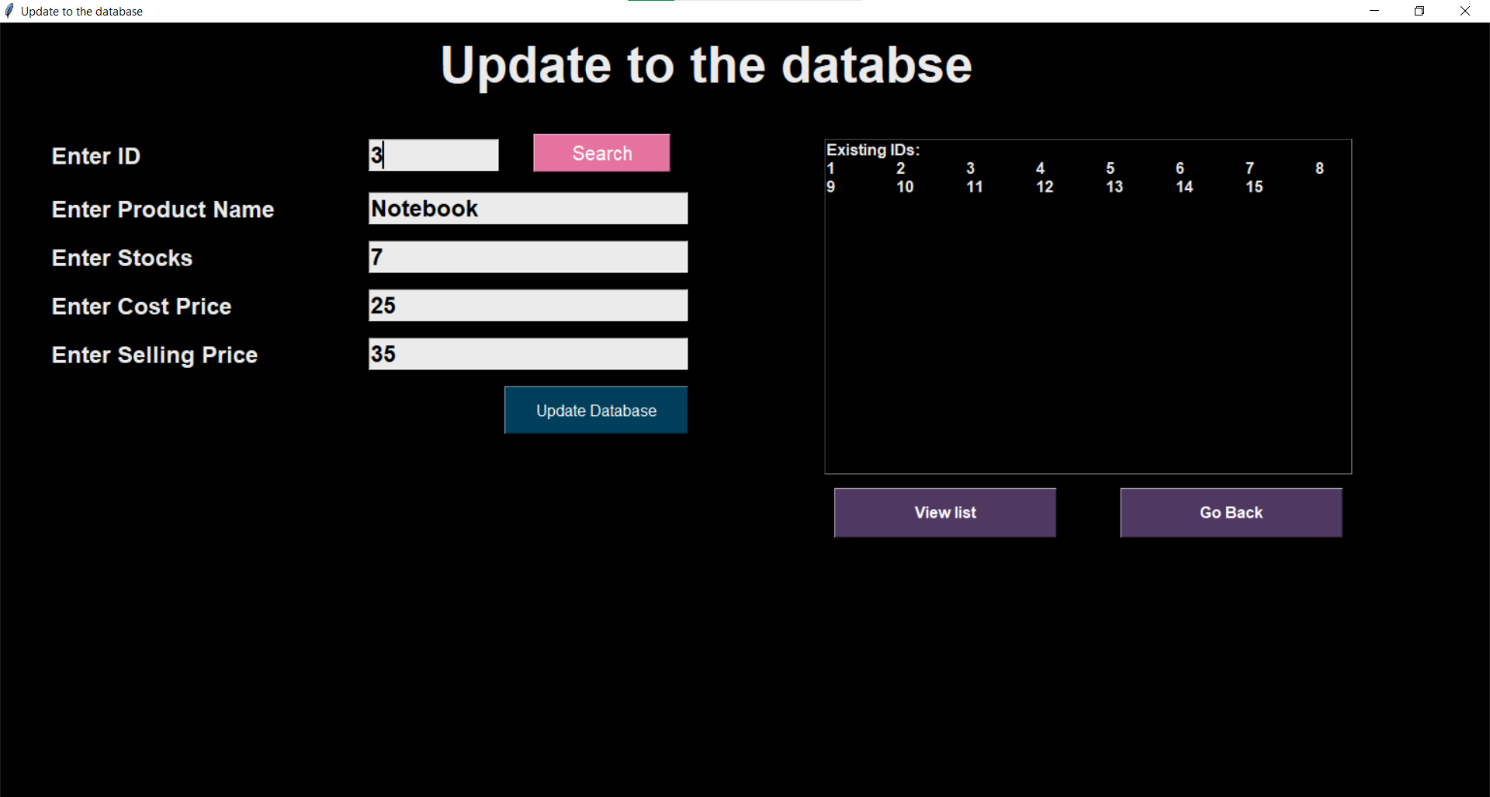

- DELETING ITEMS IN DATABASE (after clicking ‘Delete’ Button, with input values)

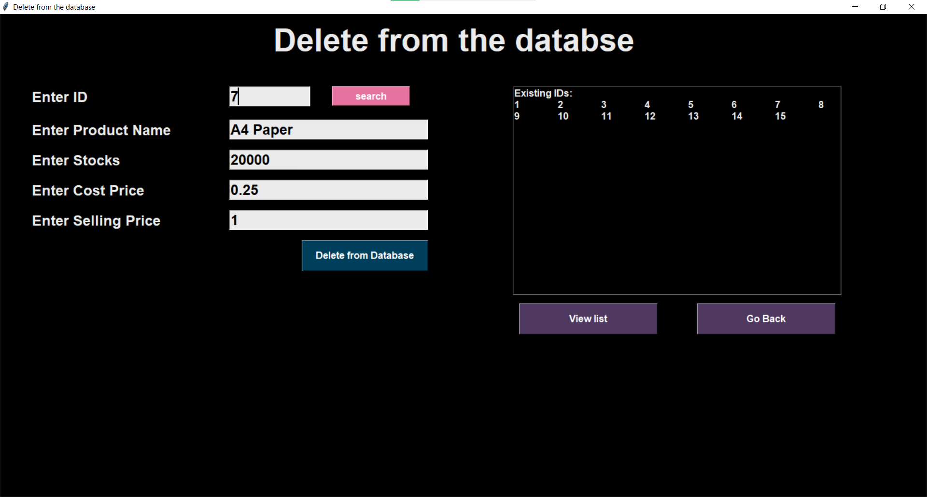

- MAIN SCREEN WITH ALL DETAILS (on clicking ‘Add to Cart’ after selecting quantity, discount and ‘Calculate Change’)

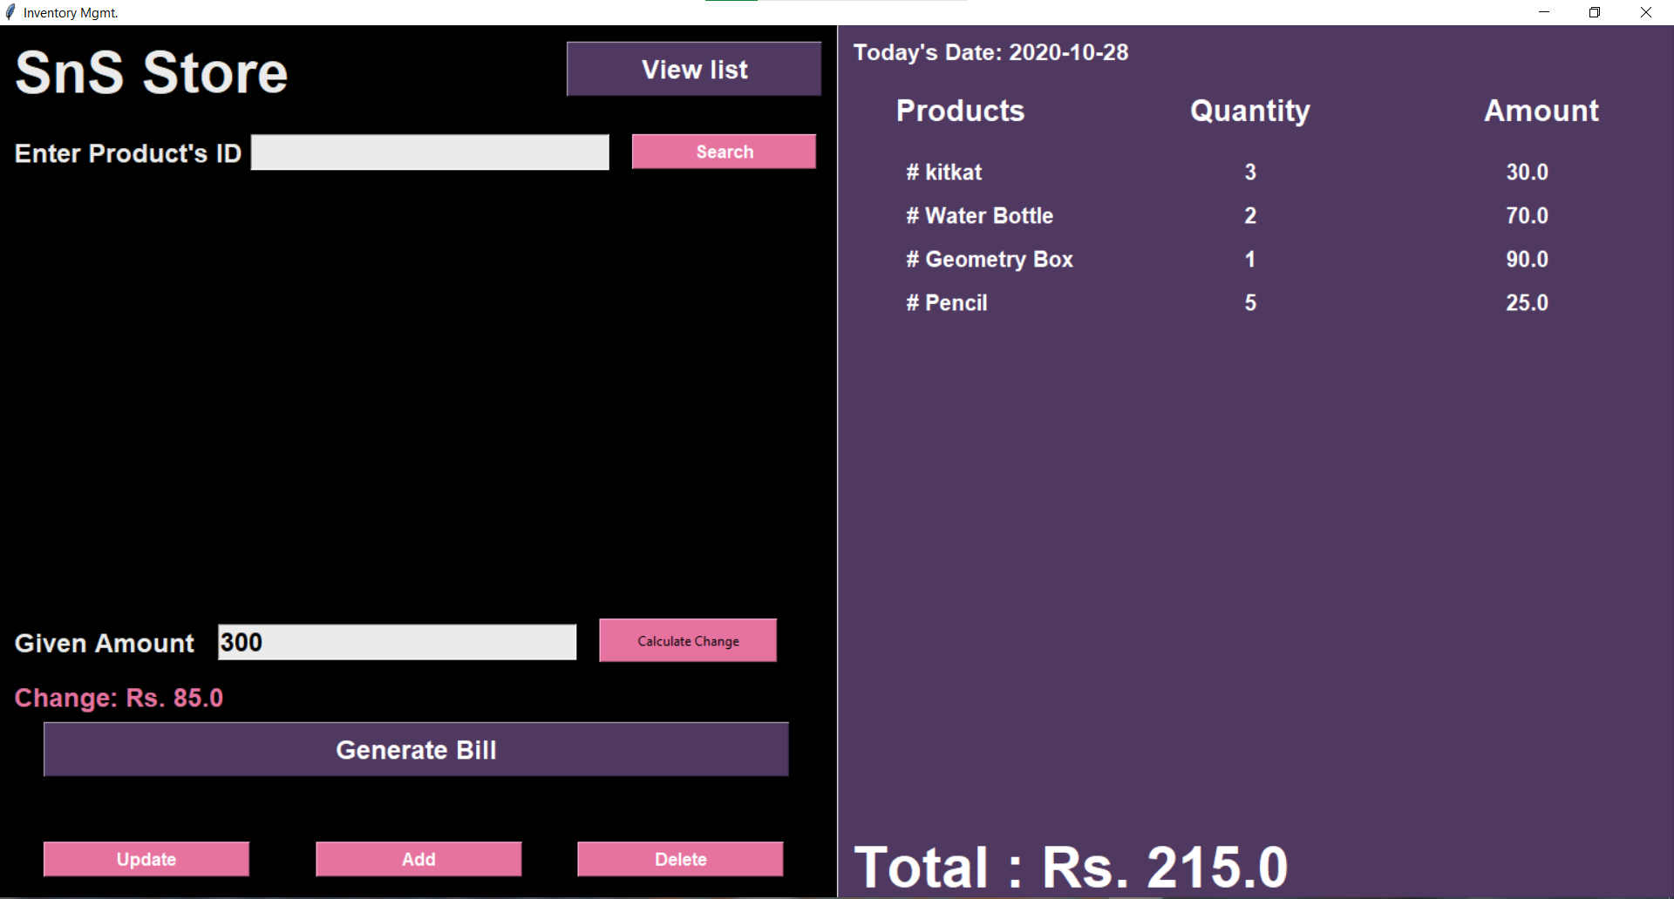

- CONFIRMATION DIALOGUE BOX (on clicking ‘Generate Bill’)

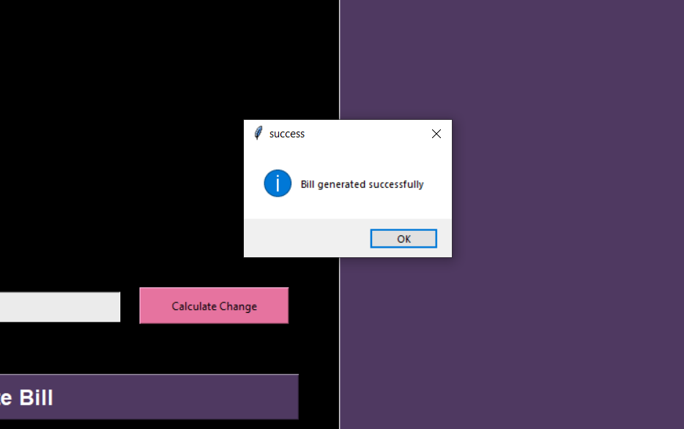

Conclusion

We finally got the product as a ‘Online Inventory Management’ that includes all the mentioned modules. We learnt how to make a GUI using Tkinter in Python and learnt to implement database connectivity using sqlite3.
The following are the end results that we yielded from our project.
- A clean and easy to use user interface without any complex settings or methods.
- Ability to Add, Update, Delete Products from the Database
- Add discounts, Calculate Change of the Products bought by the customer.
- Searching for items and adding them to the cart.

- Managing and viewing the list of items and their details available in the database.
- Error and Confirmation Dialogue Boxes incase the Seller enters a wrong Product ID, exceeds the stock, etc.

References
  - https://www.python-course.eu/index.php
  - http://effbot.org/tkinterbook/
  - https://python-forum.io/index.php
  - https://www.w3schools.com/python/
  - https://docs.python.org/3/library/sqlite3.html
  - https://stackoverflow.com/
  - www.tutorialspoint.com
  - www.google.co.in

